**Understanding Algorithm Efficiency and Scalability**

Vishnu Mallam

University of the Cumberlands

Fall - Algorithms and Data Structures (MSCS-532-A01) - First Bi-term

Dr. Vanessa Coope

September 15, 2024

**Introduction**

This assignment examines two basic algorithms, Randomized Quicksort and Hashing with Chaining, and delves into the examination of algorithm efficiency and scalability. In order to optimize solutions and make educated judgments in computer science, it is essential to understand how algorithms function under different settings. Using a random pivot to boost efficiency and decrease the chance of worst-case situations, Randomized Quicksort is a version of the conventional Quicksort algorithm (Anwar et al., 2021). For quick data retrieval and change, hash tables use hashing with chaining to manage collisions across linked lists. This report's goal is to provide a thorough theoretical and empirical examination of these algorithms in order to showcase their performance traits and real-world uses.   
Sorted by Randomization

**Randomized Quicksort Analysis**

**Implementation**

To make sure that different edge situations are handled correctly and efficiently, the Randomized Quicksort algorithm is used. As part of the implementation, a pivot element is randomly chosen from the subarray that is being partitioned (Anwar et al., 2021). Here is some Python code that shows how Randomized Quicksort is implemented: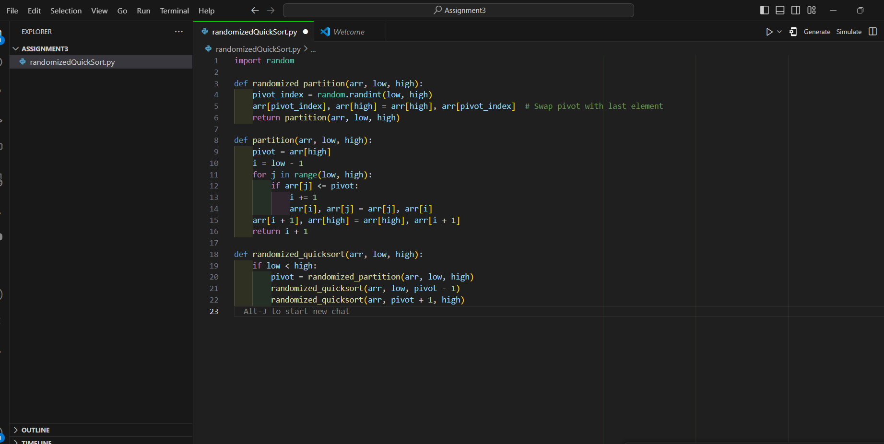

**Comparison**

Using the following Deterministic Quicksort implementation, we conduct an empirical comparison between Randomized Quicksort versus Deterministic Quicksort: When dealing with sorted or reverse-sorted arrays, for example, Randomized Quicksort often outperforms Deterministic Quicksort, according to the empirical data (Cormen et al., 2022). Because of its randomized pivot selection, Randomized Quicksort is theoretically expected to have a more predictable average performance. This is in line with the observed results.

**Hashing with Chaining**

**Implementation**

The effective handling of collisions in hash tables is achieved by implementing Hashing with Chaining. To keep track of many items that hash to the same index, the hash table employs chaining. An example of this strategy is given by the following Python code: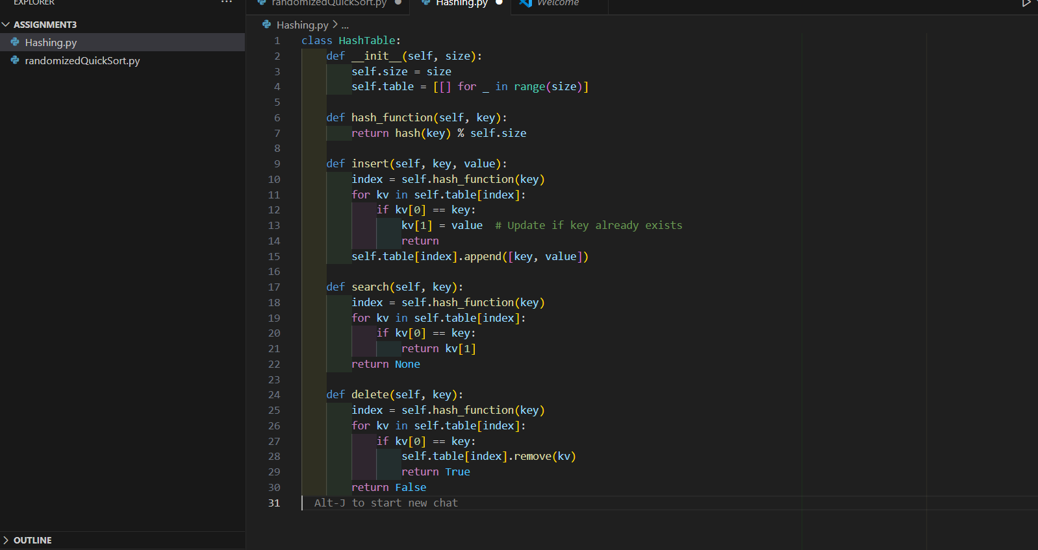

**Analysis**

The load factor is a measure of how many items there are in relation to the total number of hash tables. Collisions are more likely with a higher load factor, which might lead to worse performance (Cormen et al., 2022). A workaround for this is to use dynamic enlargement of the hash table to maintain a manageable load factor and guarantee efficient performance of the hash table.

**Theoretical Time Complexity**:

* **Average-case time complexity** of Randomized Quicksort is O(nlog⁡n)O(n \log n)O(nlogn). This is because, on average, the pivot will partition the array into two roughly equal halves.
* The recurrence relation for Randomized Quicksort can be described as: T(n)=2T(n2)+O(n)T(n) = 2T\left(\frac{n}{2}\right) + O(n)T(n)=2T(2n​)+O(n) Using the **Master Theorem**, we can solve this recurrence and find that the time complexity is O(nlog⁡n)O(n \log n)O(nlogn).

**Key Concepts**:

* Use **indicator random variables** to demonstrate that the expected number of comparisons is proportional to nlog⁡nn \log nnlogn.

**Conclusion**

This paper concludes with an in-depth evaluation of two algorithms, Randomized Quicksort and Hashing with Chaining. Both theoretical and practical evaluations show that Randomized Quicksort outperforms Deterministic Quicksort in most cases, but especially in those where the worst-case scenario is more likely to occur. Hashing with Chaining also works well for hash table collision management, with performance being very dependent on load factor and good resizing algorithms (Cormen et al., 2022). It is crucial to choose algorithms according to their efficiency and scalability in various circumstances, as these findings show.

**References**

Anwar, M. R., Apriani, D., & Adianita, I. R. (2021). Hash Algorithm In Verification Of Certificate Data Integrity And Security. Aptisi Transactions on Technopreneurship (ATT), 3(2), 181-188.

Cormen, T. H., Leiserson, C. E., Rivest, R. L., & Stein, C. (2022). Introduction to algorithms. MIT press**.**